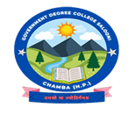
GOVERNMENT DEGREE COLLEGE SALOONI, DISTRICT CHAMBA (HP)
CAMPUS OUTREACH PROGRAMME 2024-25
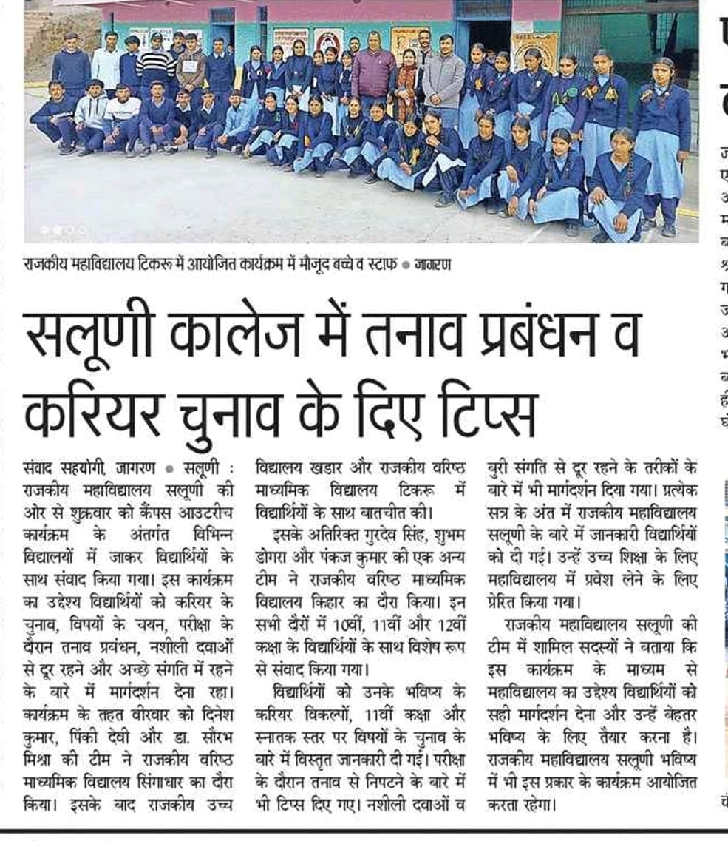
(13TH February 2025 TO 17TH FEBRUARY 2025)
